**Medication Services Billing and Documentation FAQ**

***Medication Codes and Client Plans***

**Q:** What medication service codes should be included on the client plan?

**A:**  Nursing/Medical staff should provide guidance to the Clinician who is writing the treatment plan about which medication intervention service codes will be regularly utilized. Medication intervention service codes that are not regularly utilized do not need to be added to the client plan. When selecting the medication intervention service code(s), the client’s level of stability should be considered (the higher the service code means the higher the severity of clinical presentation and complexity of services provided).

**Q**: **What does SC28 entail and does it need to be included on the client plan? Is SC28 similar to an SC70 in that it is not necessarily a “planned” service?**

**A:** The client plan should only include service codes that the program will be utilizing on a regular basis. Not every medication code needs to be included on the client plan, rather only those that are regularly used. SC28 is not necessarily the equivalent to SC70, as SC28 is not limited to being a crisis intervention medication code. SC28 should be used to document higher severity of client symptoms/history and medication service complexity.

**Q: What is the best way for clinical staff to write client plan medication code interventions that do not seem ‘cloned’ specifically for SC25, SC26, and SC27. The definitions of those codes are similar so it can be challenging for staff to write unique information to those service code interventions.**

**A:** Client plans only need to include the interventions that will be provided on a regular basis. Having fewer medication codes on the plan should help to alleviate duplication between medication codes. Interventions should focus on the client’s mental health symptoms and how services plan to address the symptoms/impairments.

***Service Code 14 Documentation***

**Q: Can SC14 be used to bill for review of outside records (such as records that come from an outside entity or hospital) in between a client’s scheduled appointments?**

1. SC14 can be used to review outside records outside of appointment times as long as the documentation indicates how the information that was gleaned from the review is being used to inform treatment.

**Q: If the Provider reviews records prior to the session, do two separate notes need to be written (i.e., one for the record review and one for the direct service time)?**

**A:** There are two options for this scenario:

1. The Provider can write two separate notes and bill separately for SC14 and medication service code, i.e., SC26 - OR -
2. The review of records can be added to service time to SC26 and the provider would clearly document what part of the service time was spent reviewing documents.

**Q: If the Provider reviews records prior to a scheduled appointment and then the client no shows, what service code should be used?**

**A:** The Provider should be mindful that for no shows, no service time should be billed for the intended service code (i.e., SC26). The Provider should write an SC26 reflecting the no show and then a separate note to bill for SC14.

***Service Code 15 Documentation***

**Q: Under what circumstances can SC15 be billed for external report preparation…**

**Q1: Can Conservatorship forms be claimed under SC15?**

**A1:** For Conservatorship paperwork, time spent on any clinical elements of the paperwork would be billable provided that the documentation clearly captures the clinical aspects, such as reviewing the diagnosis and outlining the functional impairments. Any administrative components related to the Conservatorship paperwork should be excluded from the service time.

**Q2: Can Payee forms be claimed under SC15?**

**A2:** Payee paperwork is not considered billable by DHCS.

**Q3: Can writing letters regarding emotional support animals or service animals be billable under SC15?**

**A3:** It depends. If there is a clinical element to the task, it could be billable provided that the documentation clearly shows how it ties back to the treatment plan. The majority of this task is administrative and should be excluded from service time. If providers are unsure if a particular service is billable or for documentation questions, they canreach out to QI Matters for clarification.

**Q4: Can completion of forms related to Citizenship be billable under SC15?**

**A4:** It depends. If there is a clinical element to the task, it could be billable provided that the documentation clearly shows how ties back to the treatment plan. For example, if a provider was providing documentation that the client is not able to take the Citizenship exam due to their mental health symptoms, this type of service could be billable along as the documentation clearly indicates the clinical component and how it relates to the client plan. Other aspects of Citizenship paperwork may be administrative and should be excluded from service time. If providers are unsure if a particular service is billable or for documentation questions, they canreach out to QI Matters for clarification.

**Q5: Can completion of the Application for Reduced Fare for MTS bus passes be billable under SC15?**

**A5:** For MTS bus pass Application for Reduced Fare paperwork, the time spent on any clinical elements of the paperwork would be billable provided that the documentation clearly captures the clinical aspects and how they tie back to the treatment plan. Any administrative components related to the MTS Bus Pass paperwork should be excluded from the service time.

**Q6: Can letters related to Coordination of Care, such as letters to other Treatment Providers, be billable under SC15?**

**A6**: It depends. If there is a clinical element to the task, it could be billable provided that the documentation clearly shows how it is billable. Other aspects of writing letters may be administrative and should be excluded from service time. If providers are unsure if a particular service is billable or for documentation questions, they canreach out to QI Matters for clarification.

**Q7: Can completing SSI/GR/Calfresh paperwork be billable under SC15?**

**A7:** It depends. If there is a clinical element to the task, it could be billable provided that the documentation clearly shows how it ties back to the treatment plan. Other aspects of SSI/GR/Calfresh paperwork may be administrative and should be excluded from service time. If providers are unsure if a particular service is billable or for documentation questions, they canreach out to QI Matters for clarification.

**Q8: Can preparation of legal reports be billable under SC15?**

**A8:** No, this would not be a billable service under SC15.

***Service Code 20 Documentation***

**Q: Can SC20 be used to capture time for completing TARs to submit to the pharmacy and discussion with the pharmacy about a TAR?**

**A:** Yes, SC20 can be utilized when completing a TAR as this contains information relevant to the client’s history and need for medications. In order to be billable, the progress note must include a description of the information included in the TAR as well as how it ties back to the client plan.

**Q:** **What are the documentation standards for the narrative section of SC20 progress notes?**

**A: The** Nursing Note template which is found on CCBH has prompts for required elements for SC20 notes. Although it is not required to use template and a “free flowing text” progress note can be used, the “free flowing text” progress note should still speak to the required elements.

Services for which SC20 can be used include:

* + - * Prescription refills or speaking with pharmacy.
      * Completing TARs (please see the question above for a more detailed explanation about TARs).
* SC20 can be used for reviewing of labs provided that the documentation includes the reason for service and how the labs tie into the client’s mental health treatment. The service time should equal the time it took to review the labs.

**Q: Can you please provide clarification about billing SC20 for MD staff vs. Nursing staff based on insurance of client (Medicare vs Medi-Cal) and degree of person able to provide the service?**

**A:**  Please refer to CMS guidelines for specifics on Medicare billing (some nursing services may not be billable under Medicare). For Medi-Cal, SC20 can be billed by the following degree types: RN, PHARMD, Nurse Practitioner, LVN, Physician Assistant, MD Trainee, LPT, MD, and DO.

**Q: Can the time for the time it takes to enter Rx’s in the electronic prescriber be billable under SC20 and would that time be added to the time for a psychiatric medication follow-up appointment progress note?**

**A:** The time it takes to submit the Rx in the electronic prescriber can be added to the direct service of the medication follow-up services being provided and a comment should be added, such as “X amount of time for RX input in CCBH”.

***Doctor’s Home Page (DHP) Questions***

**Q: Will programs be penalized for not using DHP to enter vitals due to social distancing and vitals not being taken at every Nursing/Provider appointment?**

1. All attempts should be made to obtain vitals. In instances where they are not checked, the documentation should reflect this as well as how the client’s vitals are being monitored and how risk related to medication safety is being addressed. In addition, if there are follow up appointments in which the client was present at the clinic (or Nursing/Provider staff met with client face-to-face) and vitals are still not being completed, this could potentially be marked out.

**Q: What is required of Nursing/Psychiatric staff when using DHP?**

1. The memo regarding requirements of DHP can be found on the Communications Tab on Optum as: [QM_MEMO_DHP_4_14.pdf](https://www.optumsandiego.com/content/dam/san-diego/documents/organizationalproviders/communications/QM_MEMO_DHP_4_14.pdf)

**Q: How can staff discontinue orders in DHP from previous providers in a way that is less time-consuming?**

1. Prescriptions are automatically discontinued if there is an end date in the Sig Builder and the end date has passed.

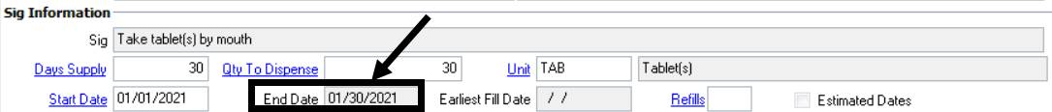

To view only the current medications, adjust the filter to “Include Current Medications only”.

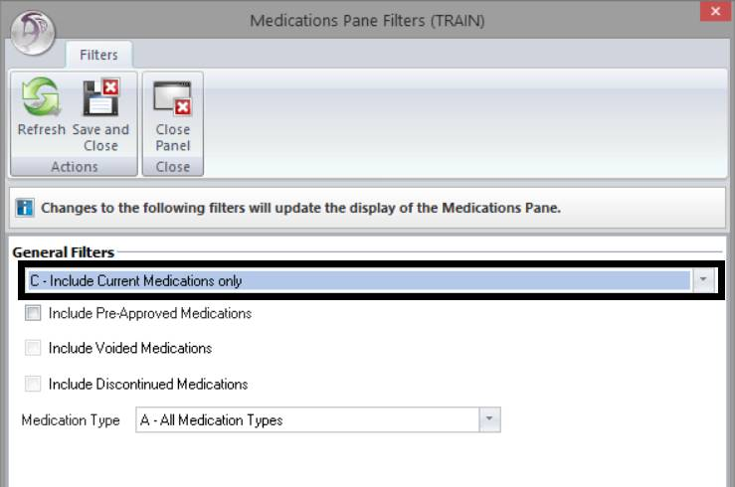

**Q. How can staff enter orders in DHP in a way that is user-friendly and less time-consuming?**

1. Staff will build fluency over time after using the DHP product routinely. It’s possible that the DHP equivalent in Cerner Millennium will be an improvement over the CCBH DHP module.

**Q. How can staff renew orders in DHP in a way that is user-friendly and less time-consuming?**

1. The process for renewing a prescription in DHP can be found in several locations:
   * It is explained on pages 68-70 in the Doctor’s Homepage Resource Packet: [Microsoft Word - DHP Resource Packet 07.2019 (optumsandiego.com)](https://www.optumsandiego.com/content/dam/san-diego/documents/organizationalproviders/training/training_resources_packets/DHP_Resource_Packet_07.2019.pdf).

* It is also illustrated in the DHP Orientation and Practice Exercises video tutorial from 21:02 – 23:35 [DHP Orientation and Practice Exercises (optumsandiego.com)](https://www.optumsandiego.com/content/SanDiego/sandiego/en/county-staff---providers/orgpublicdocs/dhp-orientation-and-practice-exercises.html).

**Q. Is it reliable to send medication orders electronically to the pharmacy?**

**A**. Selecting the “Transmit” issue method (which means sending the prescription electronically to the client’s pharmacy) is encouraged, but it is not a requirement. “Called In”, “Handwritten”, and “Print” issue method options are also available based on your preference. For reference, on a recent date (2/25/21), a total of 494 prescriptions were transmitted across our system of care - a relatively high volume. The Optum Support Desk monitors the DHP Console, which displays the status of transmitted prescriptions. Transmission errors occur infrequently, but when they do occur, Optum Support Desk staff are quick to engage Cerner for troubleshooting.

**Q. How can technical support for DHP be accessed?**

**A:** The Optum Support Desk is available 6am-6pm Monday through Friday. They can be phoned at 1-800-834-3792 or emailed at [sdhelpdesk@optum.com](mailto:sdhelpdesk@optum.com). Staff can also re-take the DHP training as often as needed as a refresher (sign up at <https://www.regpack.com/reg/optum>).

***General Questions:***

**Q: What Service Code should be used when a client “no shows”?**

**A:** For no shows, select the intended service code and then choose “no show” for the appointment type prompt.

**Q: Are the different medication codes reimbursed at different rates?**

**A:** The codes are reimbursed at the same amount, but the different codes are used to indicate severity of client presentation/functioning and complexity of services provided. The documentation in the note should be consistent with the severity of client presentation/functioning and complexity of services provided.

**Q: When should “Telephone” and “Telehealth” be used for the service type?**

1. There is a difference between “Telephone” and “Telehealth”:

* Telephone: Phone conversation, select “Provided At” being “Office” and “Contact Type” being “Telephone”
* Zoom/FaceTime, etc.: When the client is seen via a video platform, select “Telehealth” for both “Provided At” and “Contact Type”
* If hospitalized/lock out setting: Indicate the lock-out setting for “Provided At” so the service is not billed. The “Contact Type” indicated should still indicate “Telehealth.”